This is an AI automatic translation from the original file
“Bài tap tổng hợp - Lập trình căn bản - Chương 1 và 2.docx”
The language used is C Language

The photos are the "Vietnamese input" of the article, some photos may have incorrect numbers or letters, please understand.

Exercise 1:
Input two real numbers a and b from the keyboard. Display the two entered numbers on the screen in the format:
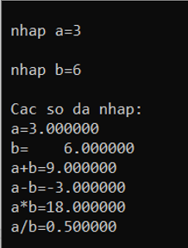
“Entered numbers:
a = (5 characters used to display a)
b = (12 characters used to display b)
Display the sum, difference, product, and quotient of the two numbers a and b in the form:
a + b = ……………
a - b = ……………
a * b = ……………
a / b = ……………

Exercise 2:
Input a real number a from the keyboard. Display the number on the screen in the format:
“Entered number a = (use 10 characters to display a, of which 3 characters are for the decimal part)”
Compute and display the value of the expression:
B = 5a³ – 4a² + 3a – 2.
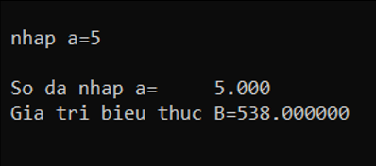

Exercise 3:
Input an integer a from the keyboard. Display the number on the screen in the format:
“Entered number a = (6 characters used to display a)”
Compute and display the value of the expression B = $\sqrt{a}+sina$.
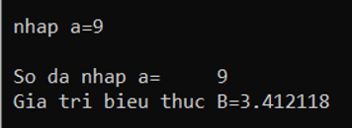

Exercise 4:
Input a real number a from the keyboard. Display it in the format:
“Entered number a = (use 8 characters to display a, of which 2 characters are for the decimal part)”
Compute and display the value of: B=lna² – tang3a
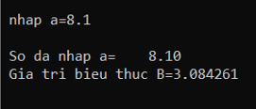

Exercise 5:
Input a real number a from the keyboard. Display it in the format:
“Entered number a = (use 12 characters to display a, of which 4 characters are for the decimal part)”
Compute and display the value: B= 5|a| - a⁵
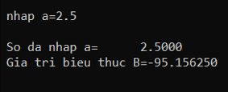

Exercise 6:
Input two real numbers a and b from the keyboard. Display them in the format:
“Entered numbers:
a = (use 5 characters to display a, with 2 decimal digits)
b = (use 5 characters to display b, with 2 decimal digits)”
Swap the values of a and b. Display a and b after swapping.
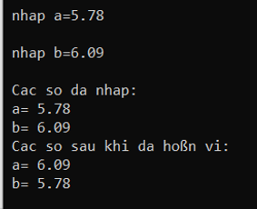

Exercise 7:
Input a real number a from the keyboard. Display:
“a = (use 8 characters to display a, with 4 decimal digits)”
Compute and display: B = 5a³ – cos3a².
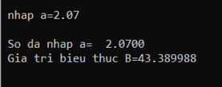

Exercise 8:
Input three real numbers a, b, c. Display them in the format:
“Three entered numbers are:
a = (2 decimal digits)
b = (3 decimal digits)
c = (in standard format)”
Compute and display the expression $B=\sqrt{a^{2}+b^{2}+c^{2}}$.
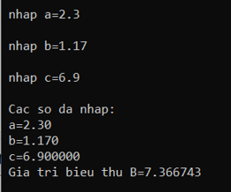

Exercise 9:
Input two integers a and b. Display the result of the expression:
(a > b) and (b + 5 != a²) or (b - 5 < a)
Display a detailed explanation as follows:
“a > b : (result)
b + 5 = (result)
a² = (result)
b + 5 != a² = (result)
(a > b) and (b + 5 != a²) = (result)
b - 5 = (result)
b - 5 < a = (result)
(a > b) and (b + 5 != a²) or (b - 5 < a) = (result)”
Try with:
- a = 3, b = 7
- a = 3, b = 2
- a = 1, b = 8
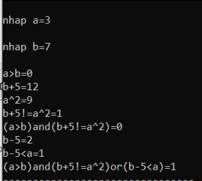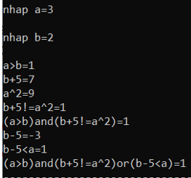
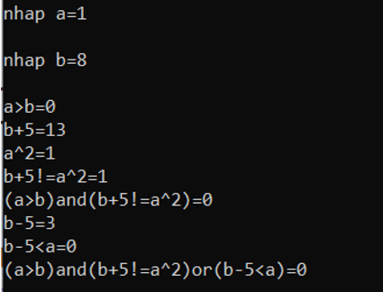

Exercise 10:
Input a real number a. Display it in the format:
“Entered number:
a = (use 7 characters to display a, with 3 decimal digits)”
Compute and display the circumference and area of a circle with radius a.
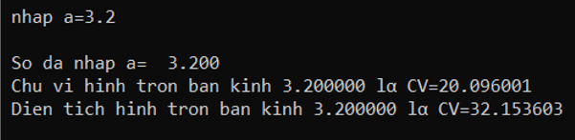

Bản quyền các file bài tập thuộc về Trường Đại học Điện lực
Copyright of exercise files belongs to Electric Power University

